*Florida International University*

*School of Computing and Information Sciences*

Feature Document

User Story ID 216

**Team Member(s):** Jordan Laing, Galo Romero

**Project:** Biosensing 2.0

**Product Owner(s)**: Shekhar Bhansali, Yogeswaran Umasankar

**Mentor(s)**: Vishal Chopade, Apurva Sonawane

**Instructor**: Masoud Sadjadi

**User Story:** Pull data from server and display in graph

### **Description:**

* As a user, I want to be able to view data that has been stored on the server in a graph.

### **Acceptance Criteria:**

1. The app connects to the database on the SQL Server
2. The app pulls data from the database
3. The app displays the data in a graph

**Use Case:**

* **I**D: 216-01 - Pull data from server and display in graph
* **Actor:** User
* **Entry Condition:** This use case starts when the user selects the temperature graph.
* **Flow of Events:**
  + The user clicks the button to select the temperature graph.
  + The system connects to the database on the SQL server.
  + The system queries the database to return the data in the temperature table.
  + The system plots the data onto a line graph.
  + The system displays the graph to the user.
* **Exit Condition:** This use case ends when the system displays the graph to the user.

**Use Case Diagram**

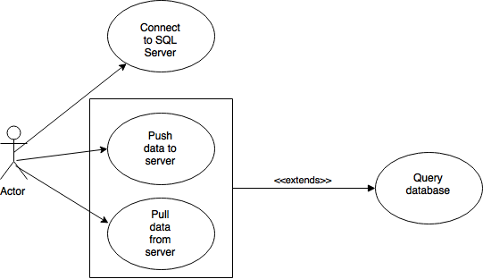

**Sequence Diagram**

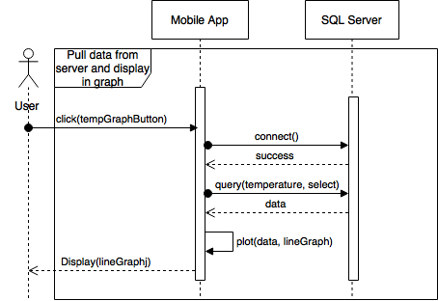

**Testing**

* Test Case ID: 216-001
* Purpose: To test if the mobile app can pull temperature data from the server and display it in a line graph.
* Preconditions:
  + Android application package installed on mobile device
  + SQL Server running on same local network as mobile device
* Expected Result: The app pulls the temperature data stored in the server and displays it in a line graph.
* Actual Result: The app successfully pulls the temperature data and displays the line graph.

**User Guide**

The user can open the temperature graph by clicking the button that says “Graphs”. This will cause the system to display a line graph with the temperature data currently stored on the server. It is likely that it will be scaled poorly, though, because of the large differences in the gaps between timestamps, as shown below.

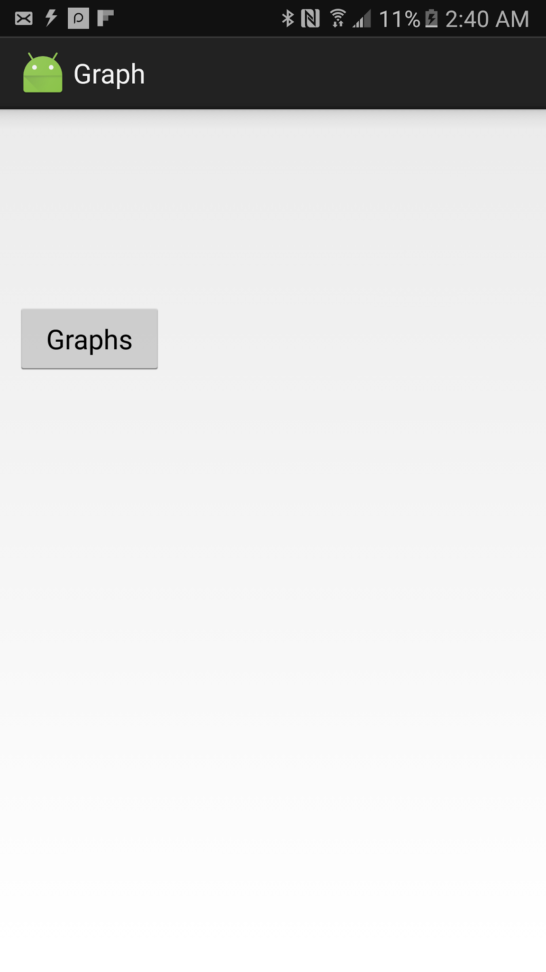 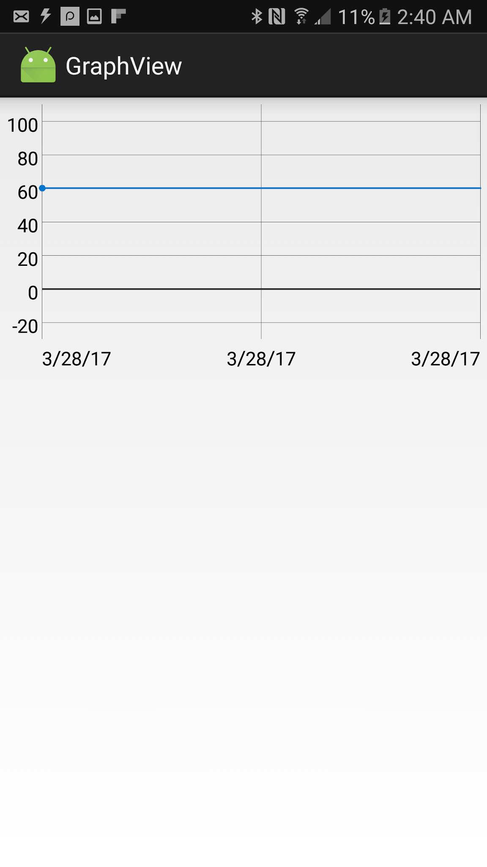

This can easily be corrected however, by the user using two fingers on the screen to zoom in and out on the graph.

